Own the Middle in 30 Minutes
U12 / G6 • 3–3–2 midfield unit • Tuesday and Thursday, 5:00–5:30 PM
Two academy-influenced sessions that move from scanning and receiving into rondo decisions, positional play, and third-player combinations. Rhythm: picture, rehearse, oppose, play.

Academy hybrid
Manchester City: Positional play: occupy different lanes, offer short and long options, then find the free player.
Barcelona: Rondo progression: scan before receiving, use the back foot, bounce under pressure, and play the third player.
Ajax: Positional rotation: move after the pass, exchange roles, and keep the team’s width and depth while rotating.
Equipment: 12 cones, 10 discs, 8 pinnies, 2 mini-goals, 5–8 balls. Fits 10–14 players; use a second lane when 12+ attend.

Tuesday • 5:00–5:30 PM

Scan. Open. Play forward.
Build the center midfielder’s habit of checking both shoulders, receiving side-on, and finding the next line before pressure arrives.

1. Scan gates
4 min • ball each — Fast activation: eyes leave the ball before the player crosses a gate.
SET IT: Mark a 12 × 12 yard square. Make four 2-yard gates inside with two colors. Every player has a ball; coach stands outside with two colored discs.

Step 1
Players dribble freely with small touches; no lines and no standing. | 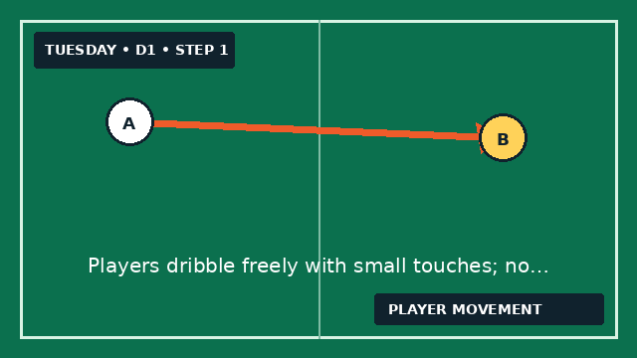

Step 2
Before entering a gate, the player checks over one shoulder toward the coach. | 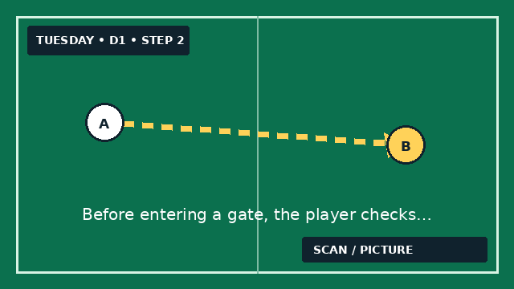

Step 3
Coach raises a color. Player says the color out loud, then exits through a gate of the opposite color. | 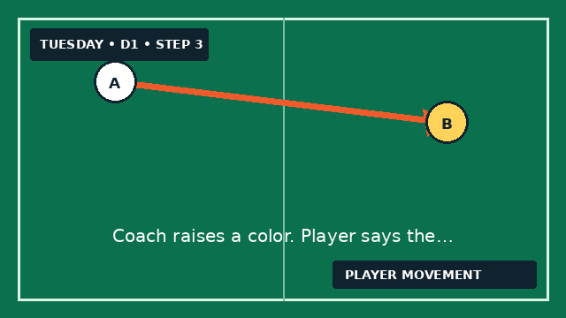

Step 4
At 2:00, require a turn on exit: inside cut, outside cut, or pull-back. | 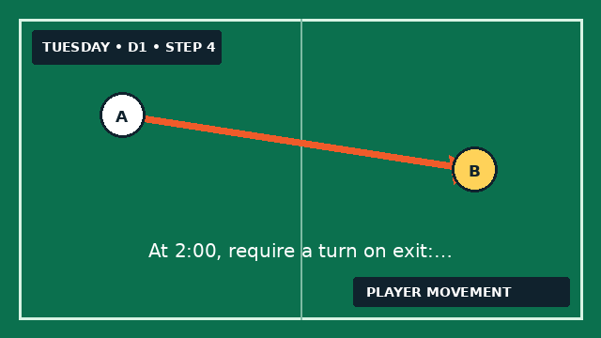

Step 5
At 3:30, freeze once: ask two players what they saw before they turned. | 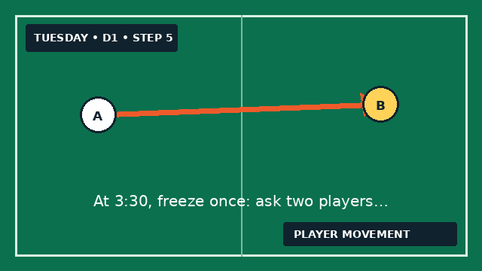
Coach detail: Coaching detail & fix Say • “Picture before touch.” • “Soft knees, head on a swivel.” • “Push into space after the gate.” If heads stay down: remove the balls for 20 seconds, rehearse shoulder checks while jogging, then add them back.

2. Rondo entry triangle
8 min • groups of 3–4 — Use rondo habits—scan, receive across the body, and play the free side—so the second pass can travel forward in two touches.
SET IT: Build triangles with 8-yard sides. One player at each cone; extras start at A. Put two balls at A. B begins side-on, able to see A and C.

Step 1
A shows the ball and waits until B checks away, then sharply checks back. | 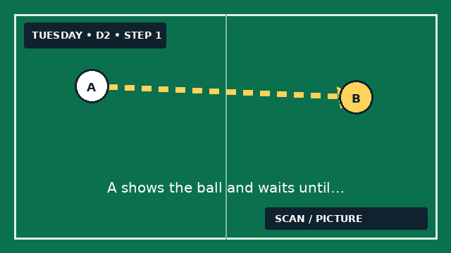

Step 2
B scans toward C while moving, opens the hips, and calls “set.” | 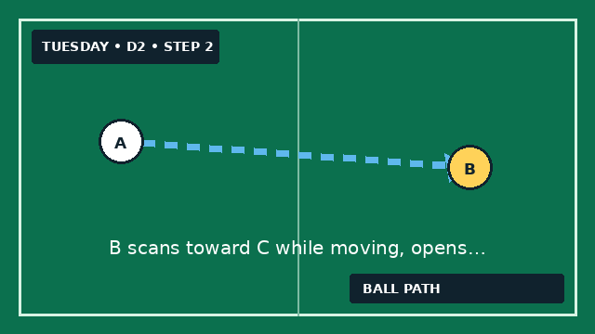

Step 3
A passes to B’s back foot—the foot farthest from A. | 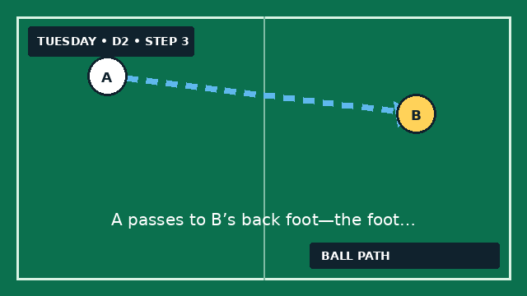

Step 4
B’s first touch travels across the body; second touch passes to C. | 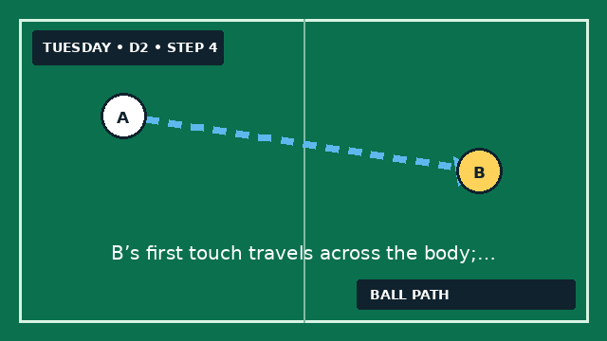

Step 5
Everyone follows the pass: A→B, B→C, C dribbles around the outside to A. | 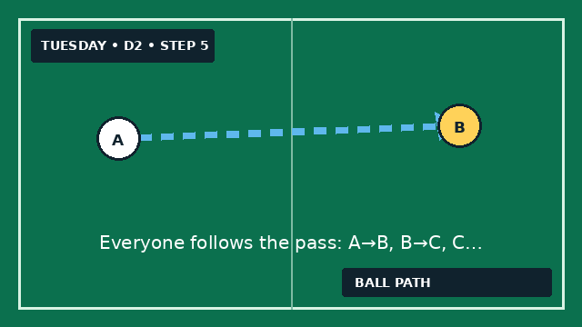

Step 6
At 4:00, reverse direction. At 6:00, allow one-touch only if the scan was early. | 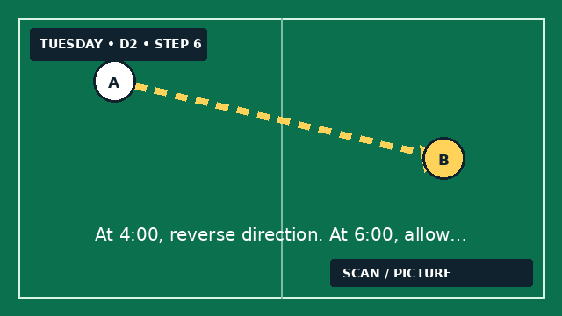
Coach detail: Coaching detail & fix Look for • Scan before the ball moves. • Back foot points at the next target. • First touch clears the cone. If B receives square: place a flat disc one yard beyond B. The first touch must land beside it, not back toward A.

3. Bounce & break
8 min • groups of 4 — Use a safe return pass to move pressure, then arrive in a new lane facing forward.
SET IT: Create a 15 × 10 yard lane split into thirds. Defender D, midfielder M, forward F, passive presser P. Start each repetition with a ball at D.

Step 1
M checks into the center third with P following at walking speed. | 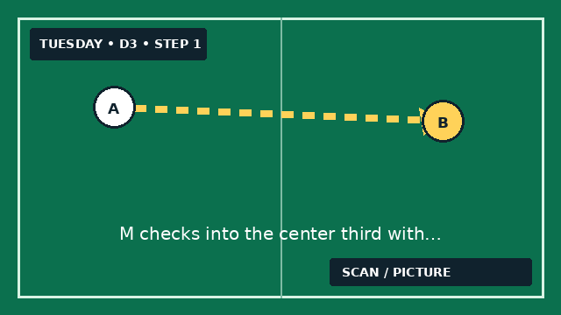

Step 2
D passes into M; M sets the ball back to D with one touch. | 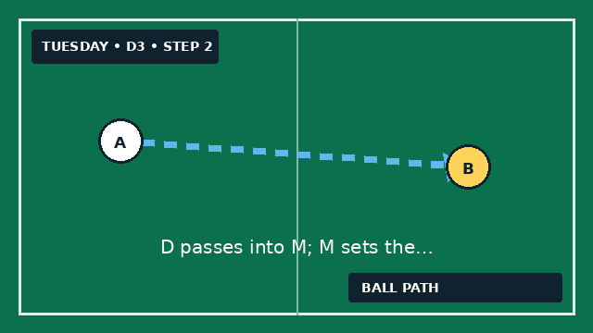

Step 3
As P follows the set pass, M spins away through either side of P. | 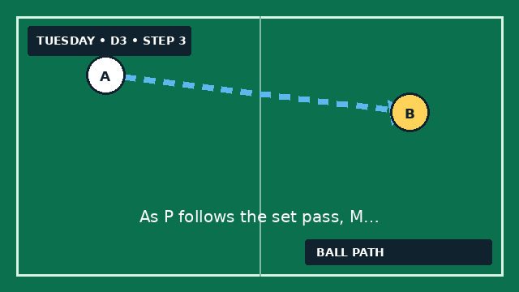

Step 4
D passes through the open lane to F; M turns to support underneath F. | 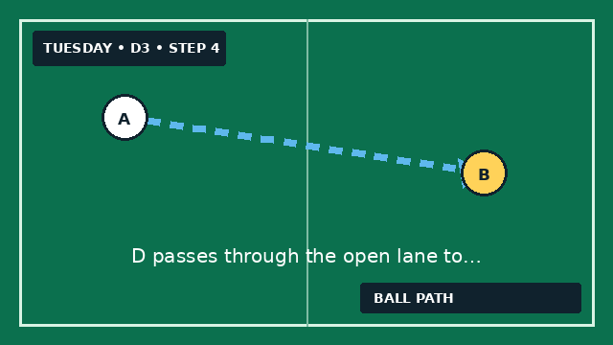

Step 5
F sets to M. M dribbles back to the start, and all rotate D→M→P→F. | 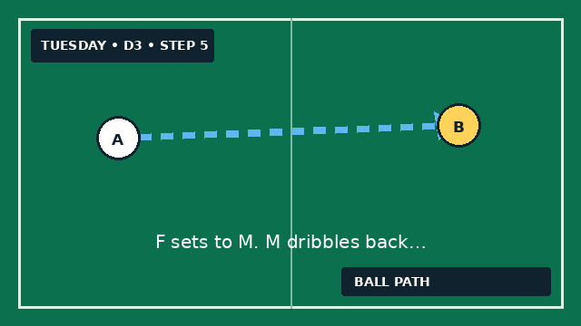

Step 6
At 4:00, P applies real pressure. Point for a clean D-to-F split; reset after 20 seconds. | 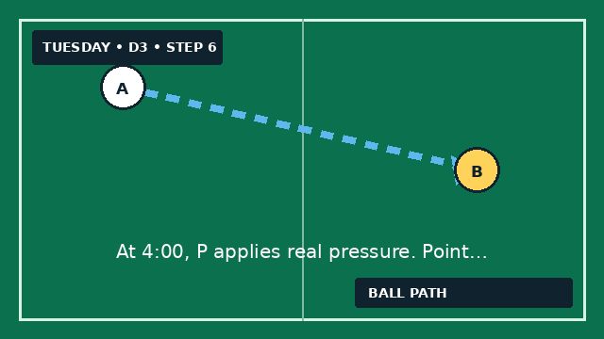
Coach detail: Coaching detail & fix Say • “Invite pressure, then leave it.” • “Set with the correct weight.” • “Spin where the defender can’t see you.” If the split closes: M must travel sideways after setting—not straight ahead—so D gets a visible passing window.

4. Directional rondo
8 min • 3v3 + 2 targets — Transfer Tuesday’s technique into a positional rondo: create width, find the spare player, and connect the far target.
SET IT: Mark 24 × 20 yards with a 3-yard target zone at each end. Play 3v3 inside; one neutral target stays in each end zone. Keep spare balls with coach.

Step 1
Coach serves to either team. That team attacks one target, then immediately turns to attack the other. | 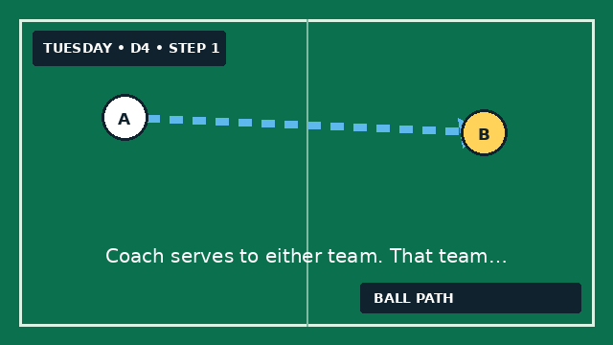

Step 2
A point requires a pass from the field into a target’s feet. | 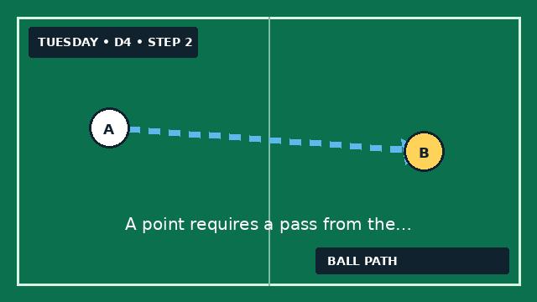

Step 3
The passer replaces the target; the target enters with the ball. Direction flips. | 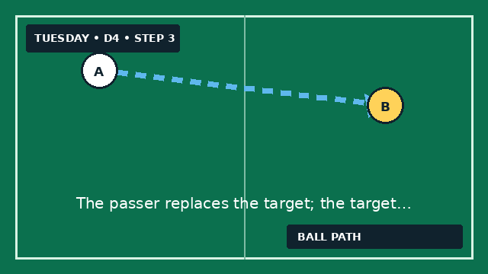

Step 4
Defenders win it and attack either target immediately—no restart. | 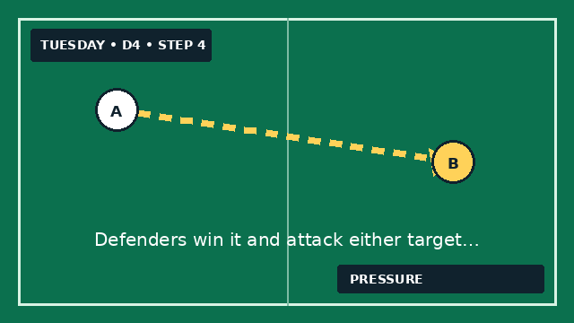

Step 5
Play 2 × 3-minute rounds with 45 seconds between to coach one idea only. | 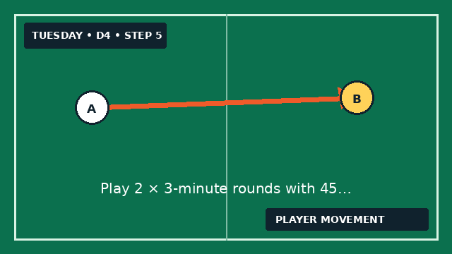

Step 6
Final minute: award two points when the receiver scans and turns forward before scoring. | 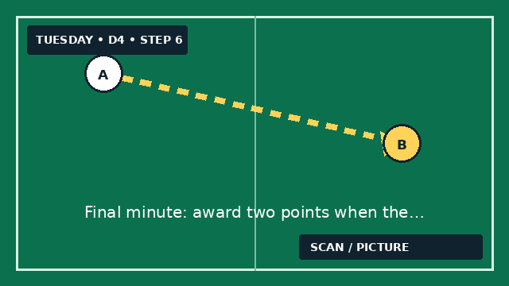
Coach detail: Coaching detail & fix Freeze only for • Midfielder hidden behind a defender. • Receiver square to the ball. • Two teammates occupying one lane. Guided question: “Where can you stand so one glance shows the ball, the defender, and the far target?”

Thursday • 5:00–5:30 PM

Connect. Support. Split lines.
Turn Tuesday’s receiving habits into midfield combinations: a third-player run, a line-breaking pass, and instant support around the ball.

1. Color-call pairs
4 min • pairs — Reconnect scanning, passing weight, and movement from Tuesday—at game speed.
SET IT: Pairs face each other 6 yards apart. Put an orange and blue cone 3 yards behind each player. One ball per pair; lanes are 5 yards wide.

Step 1
A passes to B, then checks a shoulder to see which color coach holds up. | 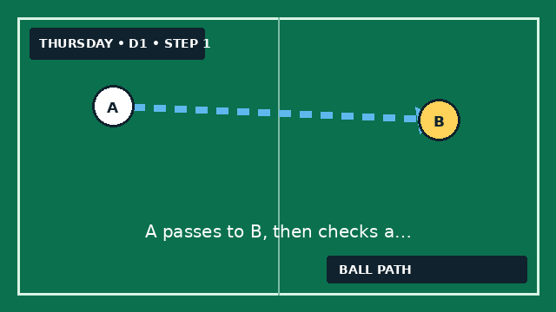

Step 2
A backpedals around that colored cone and returns to the passing lane. | 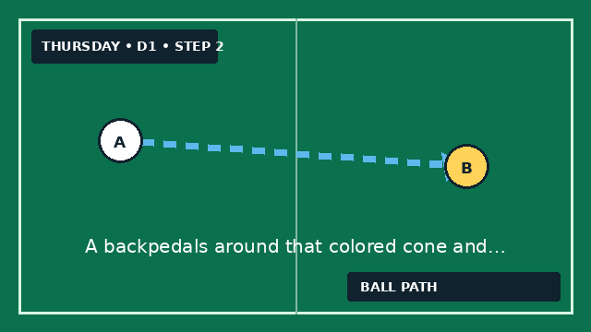

Step 3
B receives across the body, passes to A’s new position, then checks coach’s next signal. | 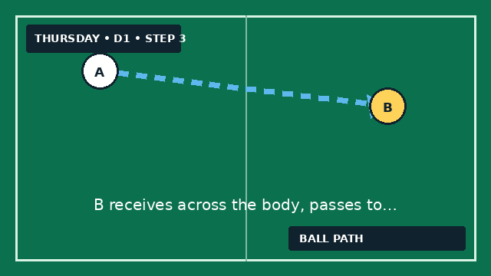

Step 4
Continue without stopping: pass, scan, loop, show. | 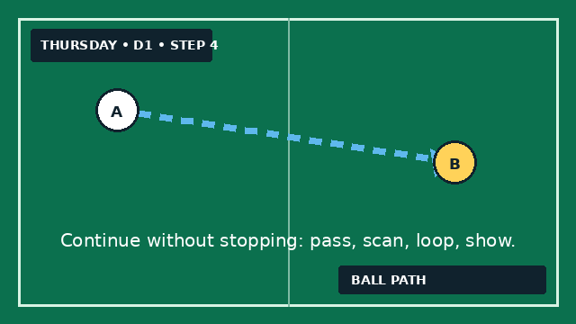

Step 5
At 2:00, use the weaker foot. At 3:00, add one-touch passes when the angle is clean. | 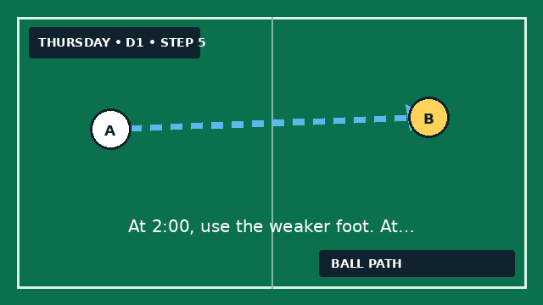
Coach detail: Coaching detail & fix Say • “Move while the pass travels.” • “Show a clear front foot.” • “Match the pace of the pass.” If rhythm breaks: widen to 8 yards and allow two touches. Speed returns only after accuracy.

2. Third-player diamond
8 min • groups of 4–5 — Play through a marked teammate by using the free player facing forward.
SET IT: Four cones form a 12 × 12 yard diamond. One player per cone; extras wait at A. Ball starts at A. The sequence always uses three passes.

Step 1
A passes diagonally to B and follows the pass. | 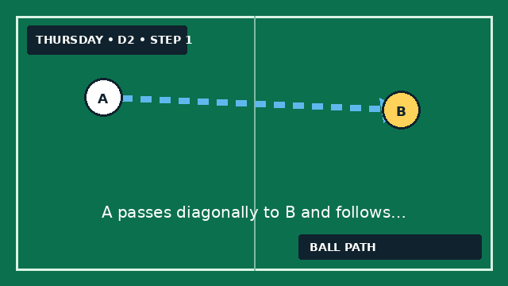

Step 2
Before the ball reaches B, C moves inward and says “set.” | 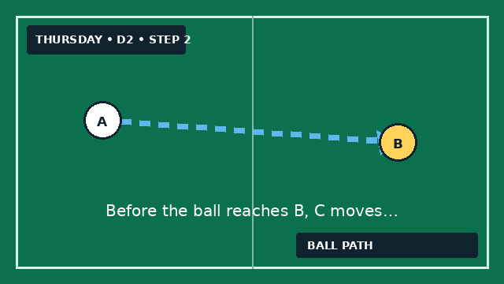

Step 3
B cushions a one-touch set into C’s path; B does not turn. | 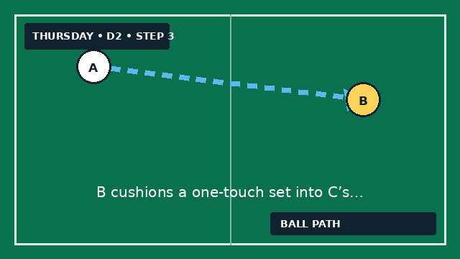

Step 4
C plays first or second touch forward to D. | 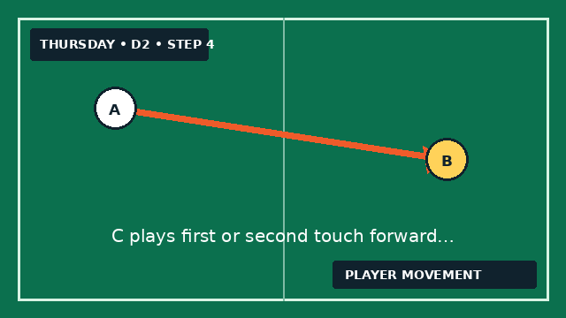

Step 5
Rotate A→B, B→C, C→D, D dribbles outside to A. | 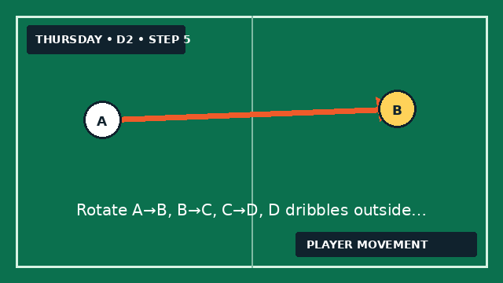

Step 6
At 4:00, reverse the diamond. At 6:00, add passive pressure behind B. | 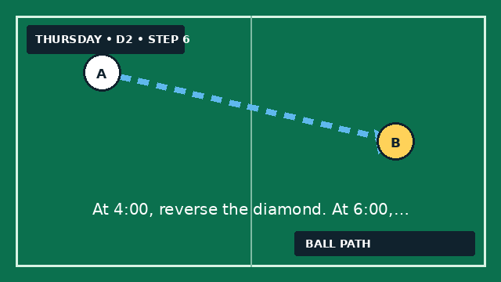
Coach detail: Coaching detail & fix Timing cues • C moves as A’s pass leaves. • B sets at an angle, not straight back. • D stays high until C receives. If C arrives early: make C touch the cone as A begins the pass. Movement should meet the ball, not wait for it.

3. Split the line
8 min • 3v2 + target — Recognize when to play through two defenders and when to recycle to create a better lane.
SET IT: Mark 18 × 12 yards. A and B work on one end with midfielder M; two defenders protect the middle; target T waits at the far end. Start with A.

Step 1
A and B can pass to each other or into M. M may move anywhere in the first half. | 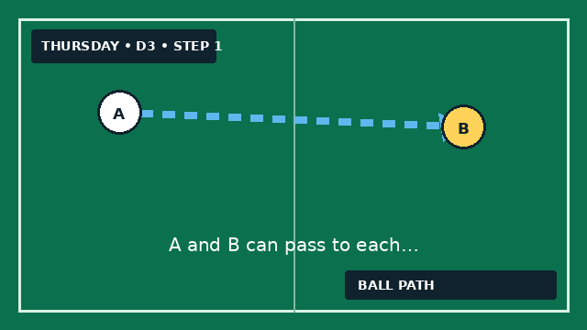

Step 2
The attackers score by passing between the two defenders into T. | 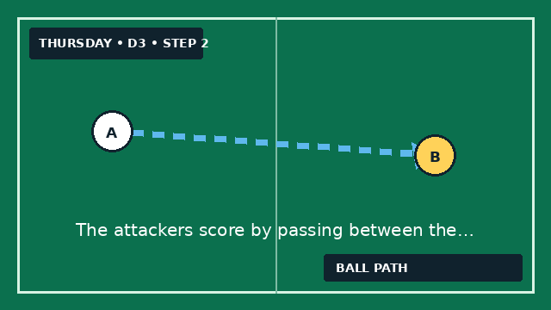

Step 3
M earns a bonus point by receiving side-on and playing T within two touches. | 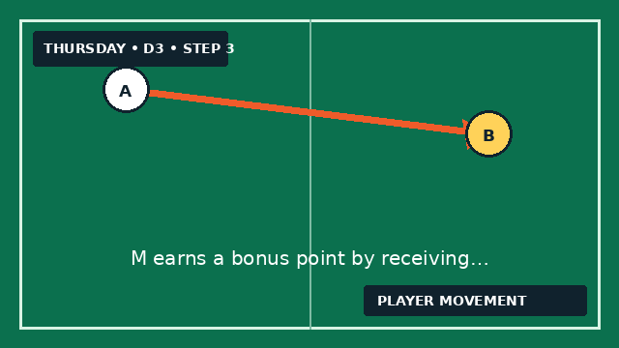

Step 4
Defenders score by winning and dribbling over the starting end line. | 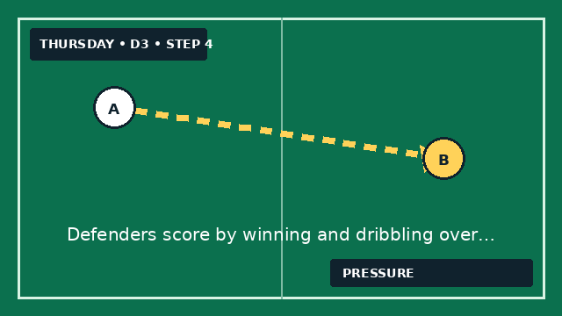

Step 5
After every score or ball out, restart with A or B. Rotate defenders every 90 seconds. | 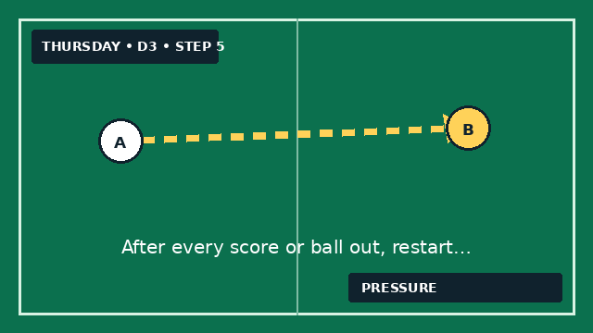

Step 6
At 5:00, allow M to run beyond the defenders after a bounce pass. | 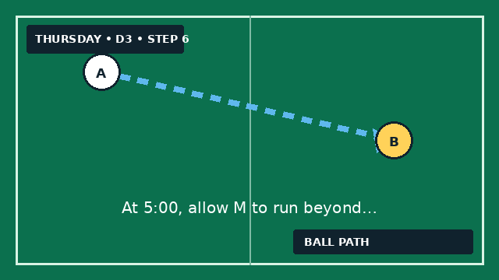
Coach detail: Coaching detail & fix Ask • “Can one pass beat both?” • “Who moves a defender first?” • “If the gap closes, where’s the spare player?” If players force it: count one point for three consecutive passes, two for the split. Recycling is a weapon, not a failure.

4. Positional rotation game
8 min • 4v4 + 3 neutrals — Use the center midfielder as the link while the wide midfielders stretch, support, and rotate without collapsing the team’s shape.
SET IT: Mark 28 × 22 yards with end zones. Play 4v4 inside, one neutral target in each end zone, and one neutral midfielder inside. Neutrals play with the team in possession.

Step 1
Start from an end neutral. Possession team tries to connect the opposite end neutral. | 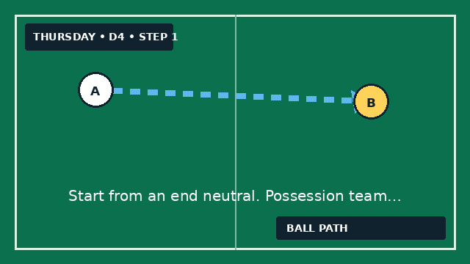

Step 2
A point counts only if the center neutral touches the ball during the attack. | 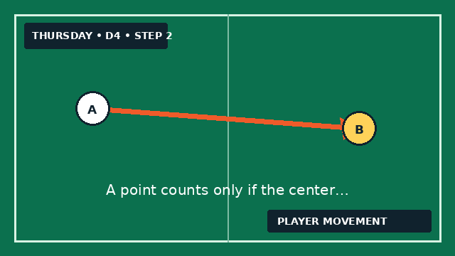

Step 3
On reaching the far end, keep possession and attack back the other way. | 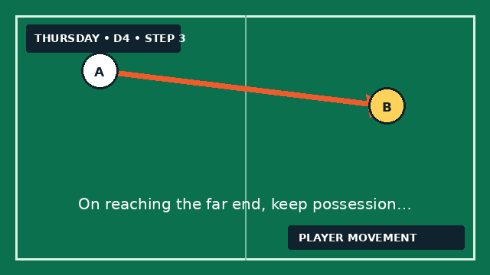

Step 4
After a turnover, the nearest player pressures; teammates immediately make one short and one long option. | 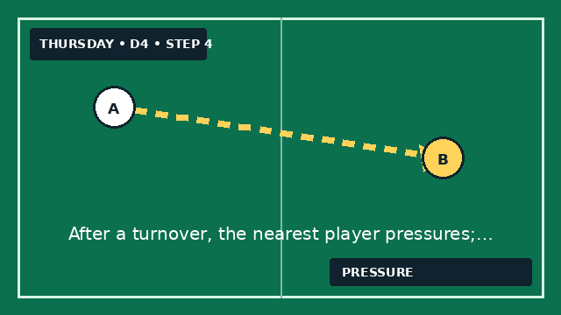

Step 5
Play 2 × 3-minute rounds. Between rounds, ask players to show the 3–3–2 midfield triangle with their bodies. | 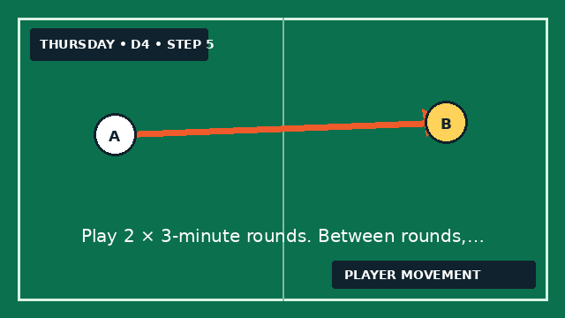

Step 6
Final minute: two points for a third-player combination that connects an end target. | 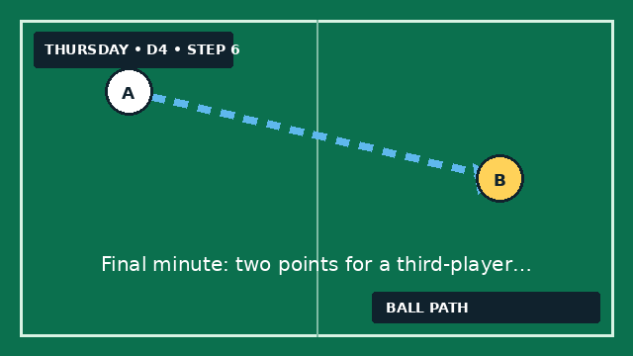
Coach detail: Coaching detail & fix 3–3–2 picture • Center mid stays on a different line from wide mids. • Far wide mid tucks in to support. • Near wide mid gives width. Game-day link: “When our defender has it, show three different doors: wide, center, and beyond.”

Two-minute close
Bring the group into the center circle. Tuesday: “What must happen before your first touch?” Thursday: “How can a teammate without the ball become the third player?” End by naming one behavior you saw, not a result.
Game-day language: “Scan early. Arrive side-on. If you can turn, go. If you can’t, bounce it and move. Give the ball carrier three different doors.”

